Carb rebuild
Two years ago I purchased a old Honda 750 rescued from a barn in Oslo. Although it was a lot older than myself being made in 1981, it was in pristine condition. Its only issue being a stubborn carburetor, clogged by the years of neglect.
This being my very first carb rebuild, gave cause to document it from start to finish which served very useful during the rebuild.
I chose the winter months to start the project since the bike was already in storage and let me disassemble it for repair.

To start I needed to understand how the carburetor worked in detail
The carburetor
As a fluid runs through a pipe and and if the diameter of the pipe suddenly decreases, the decrease in diameter of the pipe would cause the velocity of the fluid in the pipe to increase in order for it to maintain the same mass flow rate. This increase in velocity would cause a decrease in static pressure at that point.
Carborators use this decrease in pressure to pull fluid from the fuel tank up and into the air flowing into the engine. The air flow within the pipe (carborator) is driven by the suction stroke of the engine.

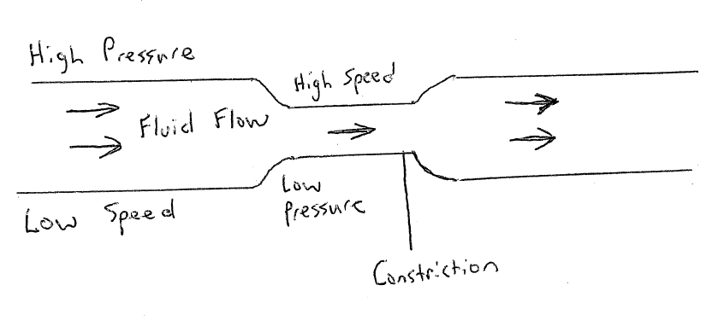

However you might have noticed that there are two control cables going down into the carburetor. One connected to the motor bike choke and the other connected to the accelerator.
The choke works by restricting air into the carburetor by closing the butterfly valve at the front of the carb. The Suction stroke from the engine then pulls fuel from the carburetor and into the engine ,creating a fuel rich mixture.
The throttle on the bike works by opening the butterfly valve closest to the engine body. This allows the carburetor to pull of the set air fuel mixture into the engine

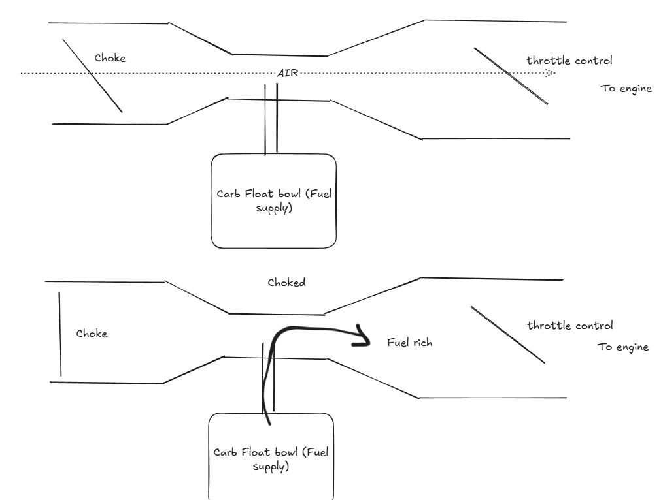

However, this would mean that the carburetor has the carburetor has to keep the air-fuel ratio correct across all engine conditions with a single fuel source. Yet, The engine’s demand changes drastically with throttle:
- Idle → very low airflow, very high local vacuum near the throttle plate
- Mid throttle → moderate airflow, vacuum shifts to the venturi
- Full throttle → high airflow, lower vacuum but large volume
To adapt the engine to different throttle levels the carburetor has different fuel jets that allow the fuel to be pulled into the air stream at different stages of the throttle. This is done by having different hole diameters from the fuel source, also known as pilot jet/slow jet (during slow throttle), needle jet (mid throttel) and main jet. The figure below illustrates when each jet kicks in to allow for a smooth fuel flow to the engine.
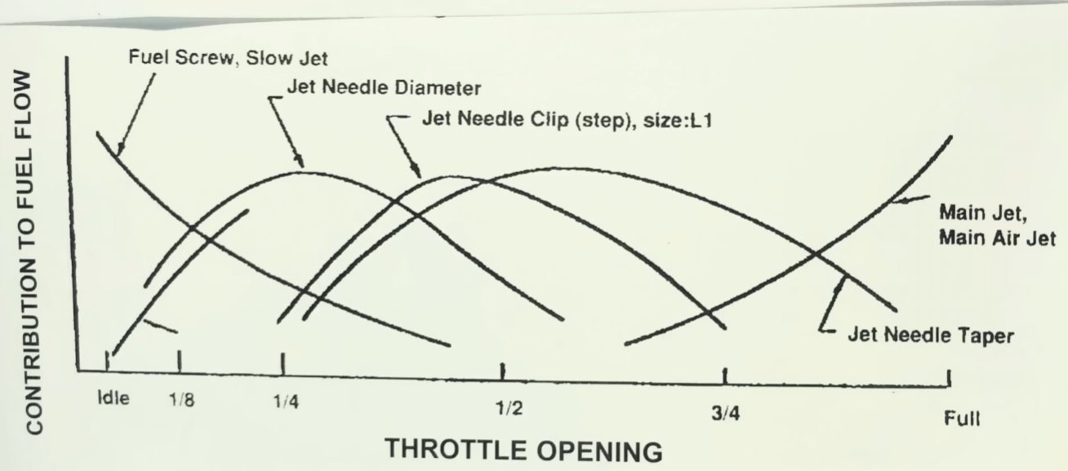

Now that we have a basic understanding of the carburetor, we can begin taking apart the carburetor.

To start, I needed to get the carburetor off the bike

Removing the carburetor from the bike

First close the fuel flow from the tank. There after loosen the screw at the botton the carbs float bowl to remove any fuel from the carb.
Thereafter, loosen the throttle cable and release it from where it is attached tot he carb. Do the same to the choke cable.
Remove all fuel and air lines connected to the carb.
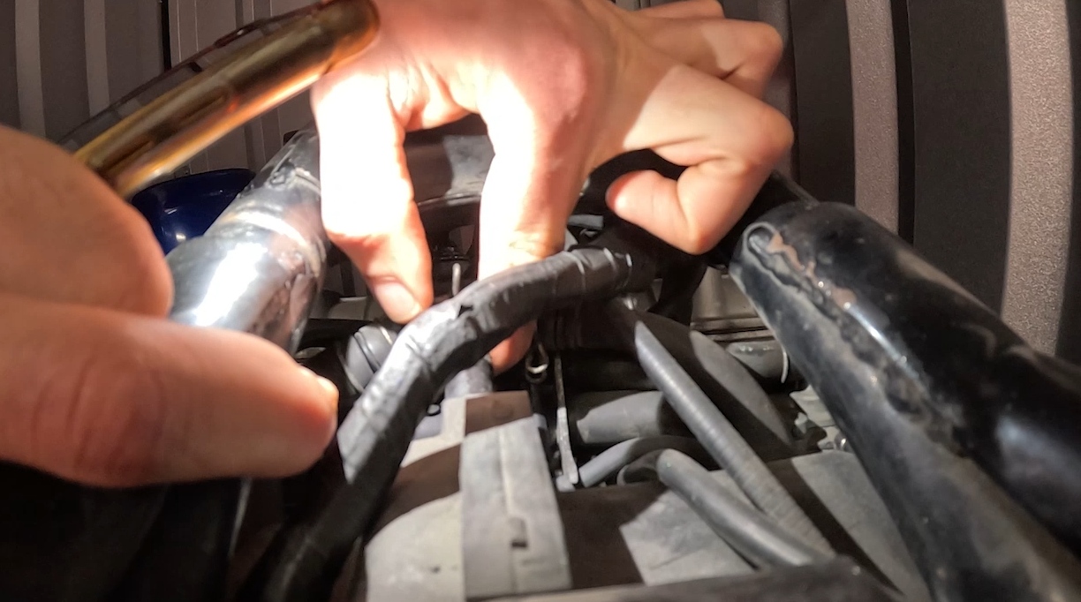
Now you can begin unscrewing the clamps connected to the engines intake manifold and the the clamps on the other side connected to the air box.

Removing the airbox

The carb on this CB750 cannot be removed without removing the airbox. Removing the airbox provides enough space for the carb to be removed.
To remove the airbox, unscrew the regulator rectifier. This gives you enough space to unscrew the air box .

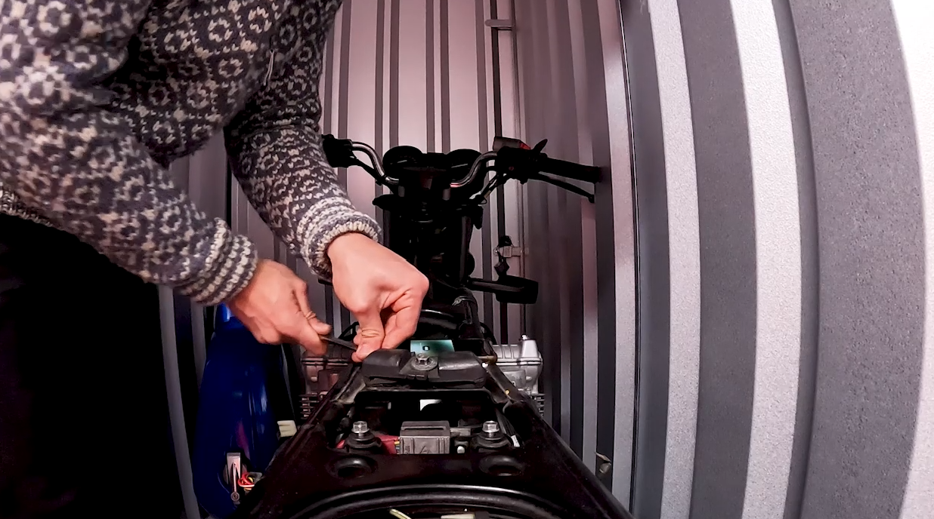
Once the airbox is out of the bike you're now able to remove the carb. Rock the carb upwards and downwards to loosen it from the rubber air flow pipes connected to the intake manifold.
Once they are off you should be able to slide the carb out of the bike body.

Splitting the carbs

Remove the fuel distribution block from the carb (the part where the fuel line comes into). There after you can begin unscrewing the top rail
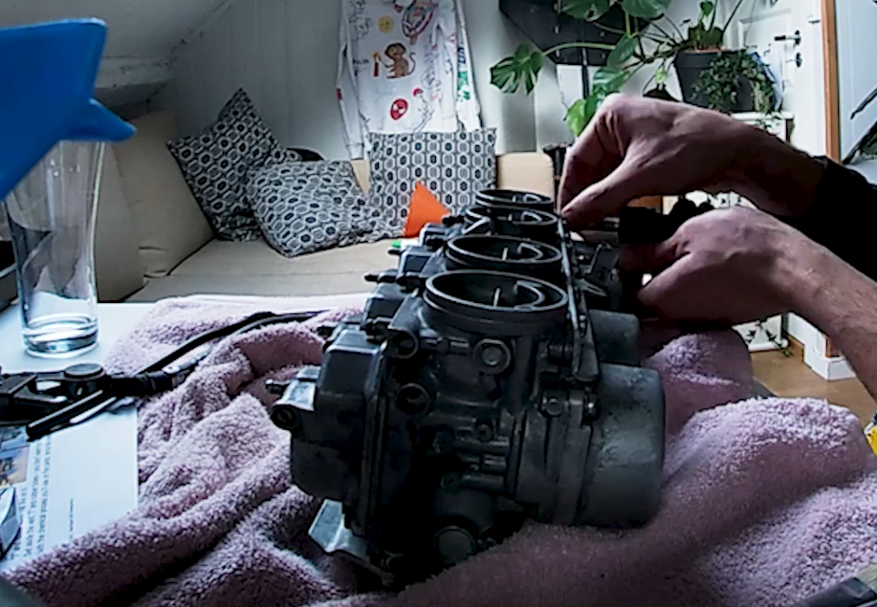

Un screw the bottom rain in a similar fashion, I needed some vice grips to help remove the screws.
The carbs are still held together by a small spring between the carbs 2 and 3. This spring synchronizes the carbs together.

Carefully unhook the small spring from the hook on the #3/4 choke shaft – it will unwind around the shaft. Split the bank in half with 1&2 as one set and 3&4 as the other set.
There arte two tubes going inbetween the carbs, the fuel rail tube (larger) and the accelerator pump tube. This is controlled by a small spring-loaded diaphragm with check valves that squirts extra fuel into the carb throat when the throttle is opened quickly, ensuring immediate throttle response and preventing hesitation from the slower-acting vacuum-operated slides. The “pump” is located in carb number 2
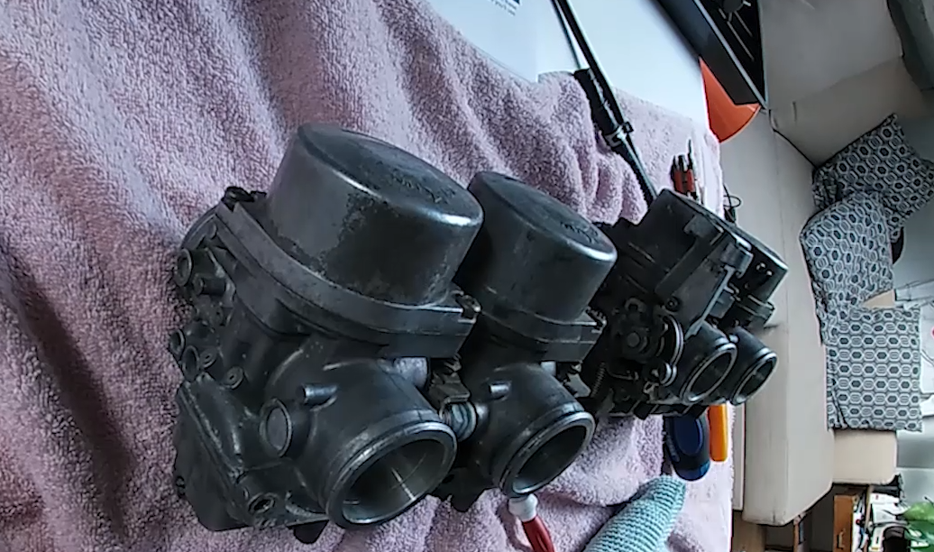

Removing the choke plate
If you look at the diagram posted above, you can see that choke plate is positioned towards the air intake.
To remove the choke plate rotate the choke shaft so that the 4 choke plate screws reaccessible. Carefully and slowly, unscrew them. Make sure you use a matching philips driver to save your self from a lot of pain afterwards.
Now you should be able to slide the choke shaft out.

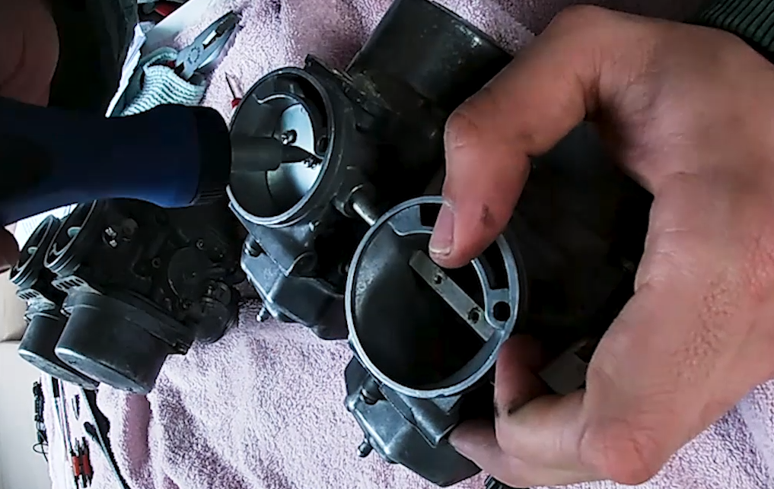

Splitting the carbs
Once the choke plates were out, I was able to plit the carbs apart. There is asmall throttle spring inbetween the carbs that I needed to be carful not to loose as well as the fuel tubs and the accelerator pump tubes..
The same was done for carbs 1 and 2, the only difference being that the choke had to be held down.

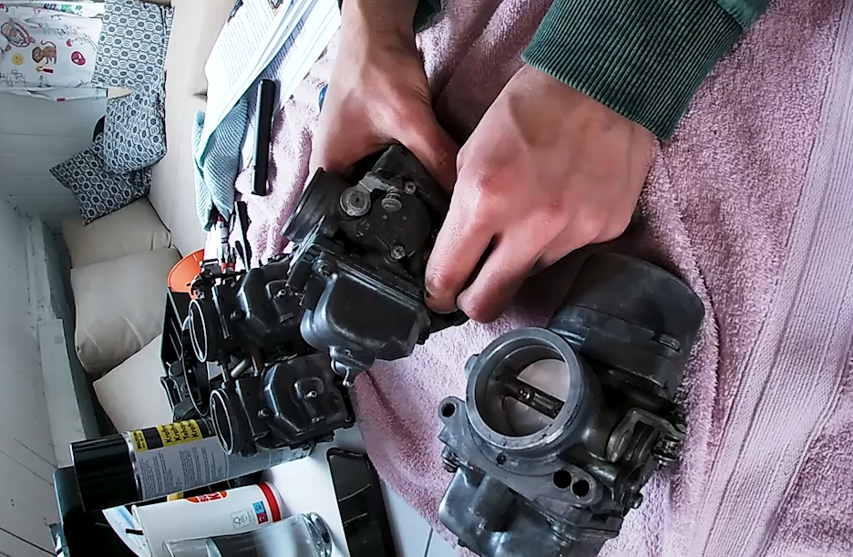

Taking apart individual carbs - Bottom end
The bottom end (float bowls) was comparatively easier to remove on my carb compared to the top end which is why I went about it first.
I began by removing the float bowl drain screws located at the very bottom. This was followed by the 3 4mm screws holding the float bowl onto the carb.
What was seen inside is the plastic float, followed by the jets and a rubber passage plug.
The plastic float makes sure that there is always a set amount of fuel in the float bowl. Damage to the plunger here can result in teh fuel overflowing once the carb is plugged back in so be careful.
The Jets were explained previously, the rubber passage plug seal internal fuel and air passages that were drilled during manufacturing. Carb bodies are made by drilling intersecting channels, then closing unused openings with rubber plugs.
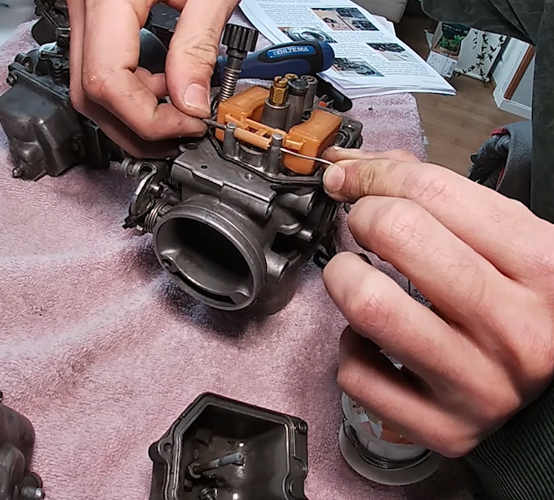

Top end
The top end was a bit tricky to remove, particularly because of the a set of stubborn screws holding it together.
To help take it apart I had to use a set of vice grips. Once the two 4mm screws were taken apart, the top end comes apart relatively easily
Insude you find the spring and the vacuum needle plunger.
Vacuum in the carb pulls the slide up when the throttle opens.
Needle rises inside the needle jet this results in more fuel delivered. The spring and puck together control movement, prevent sticking, and maintain smooth fuel flow. If the puck is missing or worn this causes jerky throttle, inconsistent fuel delivery, possible engine hesitation.
There is a small bean shaped plastic seal which redirects air though the seals or directs airflow.

Cleaning the slow speed jets.
It is very important that the slow speed jets are properly cleaned for the optimum operation fo the carbs. This was done with the help of a guitar E string with is the perfect size for the job. The slow speed jet can be seen in the image below.

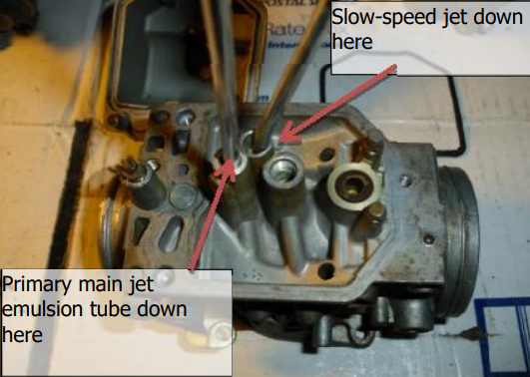

I sprayed carb cleaner doesn the slow speed jet and held my thumb ove the primary main jet hole (in the float bowl) and another finger covering the lower air cutoff hole located in the accelerator pump. I made sue that when I sprayed I could see bubbling though the pilot screw hole.
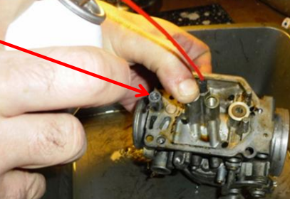

I also sprayed the the Accelerator Pump Nozzles located here
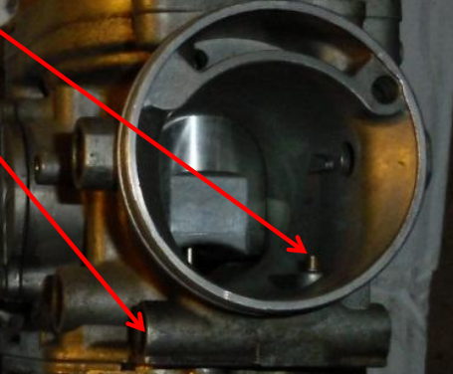

Cleaning the carb body

Once all the parts were removed from the carb they were placed in the Untrasonic cleaner.
Each part took around 40 minutes to be cleaned with the pulsed option. The result was a set of spotless carb parts.
I polished them lightly with some steel wool and some paper towels.

Assembling Individual carbs

Starting with the top part, I assembled the plastic part for the covering the air vent, followed by the plunger and the spring.
Thereafter, I installed the primary jets. Followed by the secondary jets and the emulsion tube and the rubber passage plug.
The Pilot screw was screwed in with a fresh oring.
Right before I closed the carb up, I added some water to the float bowl and closed it up. This was to verify that there are no leaks. Once I was satisfied I continued to install the float bowl and the bowl drain screws with some fresh new o-rings.

I installed the throttle body back together. This part was a bit tricky and it was very useful to have a few photos of the mechanism before I took it apart.

Assembling 1 ,2 and 3 ,4 it back together
I started with Carbs 3 and 4, these were relatively easy.
I gently twisted the accl pump and fuel rails while i brought the carbs togethr. The O rings helped firmly seat them in place.
The Sync tabs (ensures that all carbs run synchronously) need to be so that the sync tab of 4 lays on top of carb 3.
The same was done for carbs 1 and 2 with carb1 s sync tab placed over carb 2. The hardest part here was to connect the choke shaft back together.

Assembling the two halves back together
This was by far the hardest part. I needed to loosely connect the two halves together, bringing the vent tube, fuel tube, acel tube together. then attach the spring from the choke with the help of a paper clip and onto the shaft from 1 and 2. This combines the choke shaft from 1 and 2 to 3 and 4. The Sync tab from 3 was placed on top of the sync tab from 2.

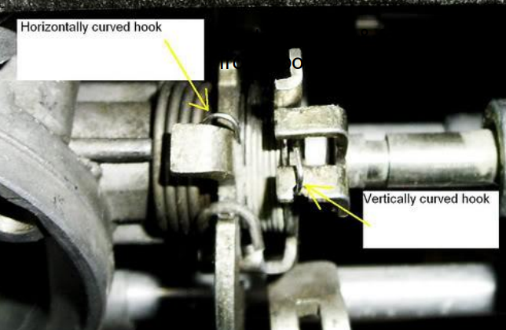

Final bits
For the final bits I replaced all the bolts on the top rail with hex bolts. I didnt tighten them all the way, instead I tighetedn them just enough to hold the carb in place. Thereafter, I attached the butterfly valves attached to the choke mechanism.
Once these are in palace, I continued to tighten the carb togogether, continually checking if the butterfly valve closes fully. All the screws on the choke plate got a dash of loc tite.

Installing the sync screws
The Sync screws were first installed between 1 and 2 and then 3 and 4. . Once this was done I continued to bench sync the carbs.

Bench syncing the carbs
This is explained in most online tutorials, the process involved holing the throttle open , adjust the sync screw so that all the thrllte vales open teh same amount (eyeballed).
Thereafter , the idle screw was turned so that the butterflied opened just enough to show one of the small holes at the base of the butterfly.
Now its just a matter of installing it back into the bike.
Installing it back into the bike.
I followed the same procedure I followed when removing the carb, swaying it back and forth until I get it onto the intake manifold hose. I did the same with the ones leading to the airbox. Thereafter, I installed the throttle cable and the choke cable to the respective slots.
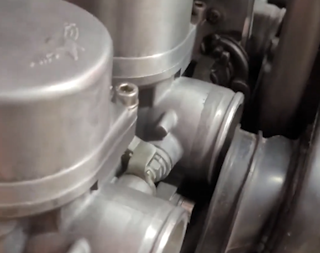

The fuel tubes were assembled as seen in the image below.

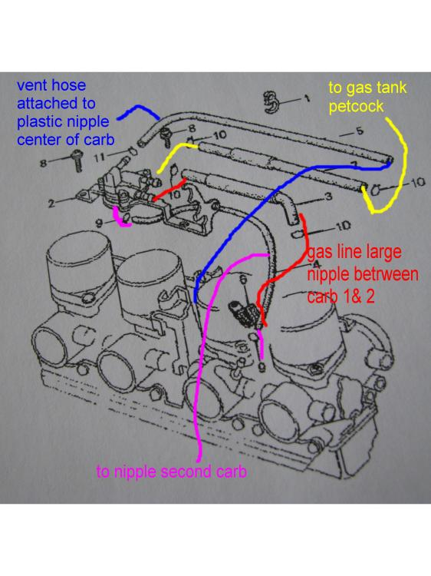
Once installed, I starred up the bike. Much to my surprise , the engine fired up perfectly fine. The Carb seemed to work perfectly fine. However I needed to make sure that the air fuel mixture was done right. This was adjusted for each carb by adjusting the pilot screw. Each adjustment was vrufyed with a short ride. Here , I checked the sparkplugs, a good air fuel mixture should have clean, unfouled and sparkplugs that have not overheated.

